1. **echo $0** – For current shell   
  
  
2**. /** (forward slash) root directory  


3. **~** (tild) home directory  


4**. pwd** – Present working directory  


5. **cd** – change directory  


6. **cd ..** – one step back  


7. **cd ../..** - two steps back  


8. **cd /** - for direct root directory  


9**. ls** – list of files  
  
10. **ll** – long list (files with details)  
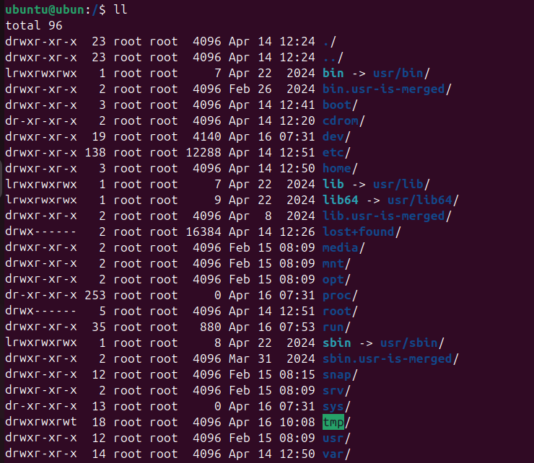

11. **ls -ltr** – same as ll, where l-long, t-time & r-reversing  
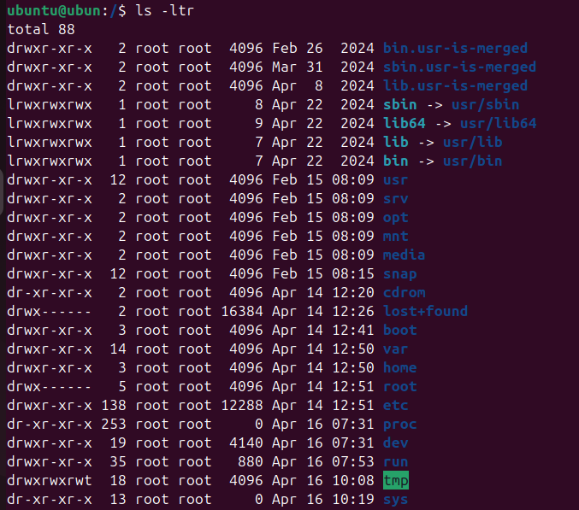

12. **ls -a** – for hidden files  


13. **mkdir** – to create directory   
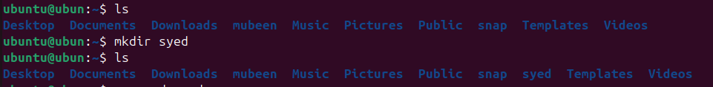

14. **mv** – to move or rename  
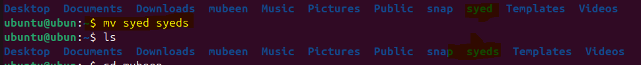  
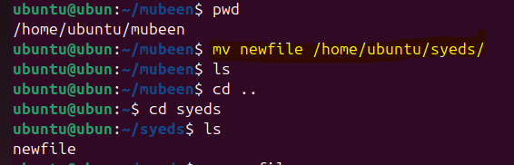

15. **rm -rf** – to delete directories  
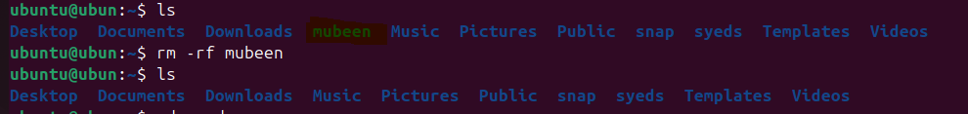

16. **cp** – copy  
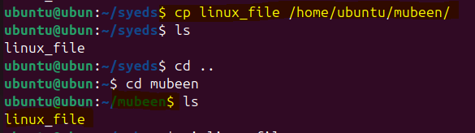

17. **touch** – to create file  
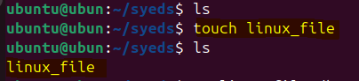

18. **vi** – to edit file   


19. **wq!** – to save file after insert   
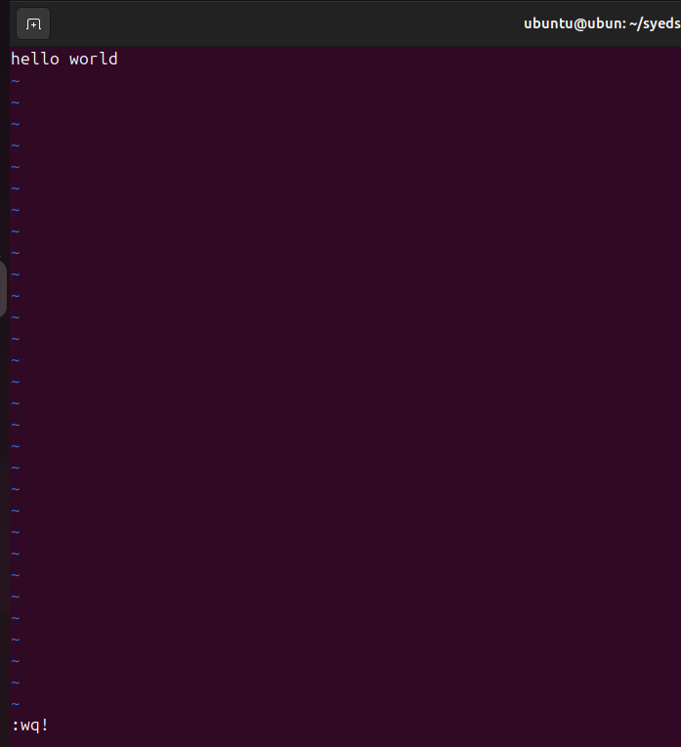

20. **cat** – to read file  


21. **rm** – to remove file  
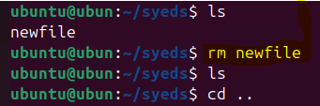

22. **wc** – for word count (lines, size, words)  
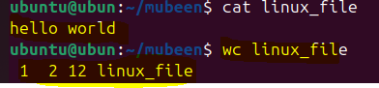

23. **date** – to check date  
  
  
24. **clear** – to clear the screen  
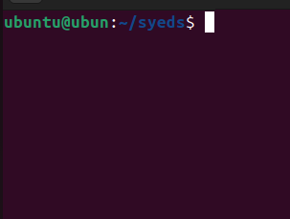

25. **history** – for history of commands  
